sun valley hoa FALL newsletter

**October 2024 Edition** **www.sunvalleyhoa.org**

**Welcome to Fall, Sun Valley Residents!**

As the season changes and the leaves begin to turn, we hope you're enjoying the crisp fall air and the beauty of our community. Here's what’s happening around Sun Valley this fall!

**Upcoming Meetings**

**1. HOA Meeting (Zoom)**  
***Date: Thursday, November 14th, 7 PM; Date: Thursday, December 12th***  
Join us for the monthly HOA meeting where we’ll discuss community updates, upcoming projects, and open the floor for any concerns or suggestions. Zoom log-in information can be found by visiting [www.sunvalleyhoa.org](http://www.sunvalleyhoa.org). Meetings are scheduled for the second Thursday of each month, unless otherwise noted.

**Community Reminders**

**1. Fall Yard Maintenance**  
As leaves begin to fall, please remember to keep your yards clear and tidy. Regular leaf removal and lawn care help maintain the beauty of our neighborhood. Let’s work together to keep Sun Valley beautiful!

**2. Pet Courtesy**  
A reminder to all pet owners: please ensure your dogs are not a nuisance to your neighbors. Excessive barking and unsupervised pets should be addressed promptly. Let’s work together to maintain a peaceful environment for everyone.

**3. Noises and Nuisances**

No nuisance shall be maintained, allowed or permitted on any part of any Lot or Common Area, and no use thereof shall be made or permitted which may be noxious or detrimental to health or which may become an annoyance or nuisance to the neighborhood.

**4. Parking**  
All motor vehicles shall be stored or parked in designated parking areas on a Lot, or designated parking areas on the Common Area, if any. All such vehicles shall be in working order, properly registered, and no repairs, except those of a minor nature, shall be permitted to the done on any such vehicles on any of the Common Area or on any Lot, unless such work is done within a fully enclosed garage on such Lot.

As a courtesy to your neighbors, please avoid parking in front of mailboxes and driveways. Let’s keep our streets safe and accessible for everyone.

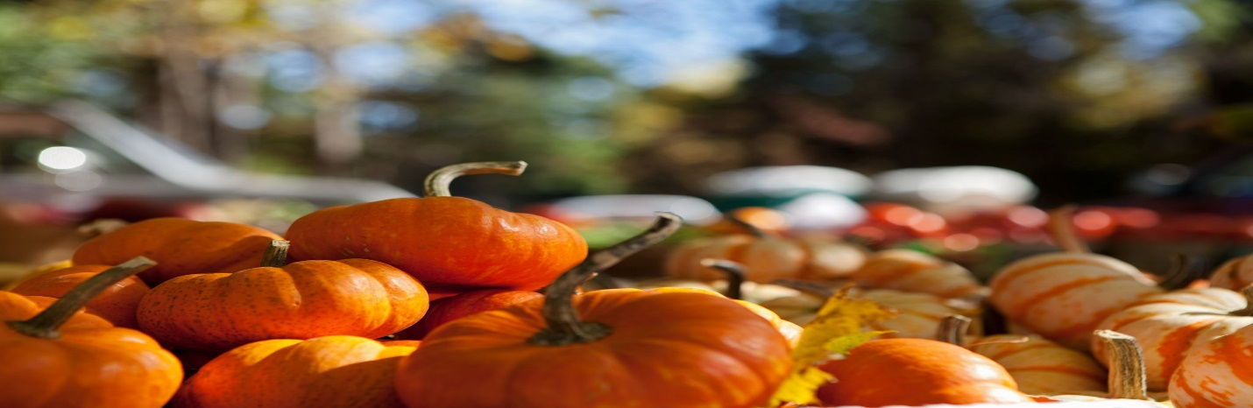

**Seasonal Tips**

* **Prepare Your Home for Colder Weather:** Check windows and doors for drafts, service your heating system, and clean out your gutters to prevent clogs.
* **Halloween Safety:** If you’re handing out treats this year, make sure walkways are clear, and consider using battery-powered candles in your pumpkins for safety.

**Community Announcements**

* **Annual HOA Notices:** It's almost time for your annual HOA packet! Please keep an eye out for this important mailing, which will contain valuable information about our community, upcoming events, and any important updates. We are pleased to inform you that there will be no increase in the 2025 HOA dues. The dues will remain at $232.00 annually.

All notices will be mailed directly to homeowners, so please ensure your mailing address is up to date. If you have recently moved or changed your address, please ensure we have the correct mailing information. Simply send your updated address to **svboardmembers@sunvalleyhoa.org** to avoid missing any critical updates.

**Contact Us**

If you have any questions, concerns, or suggestions, please don’t hesitate to reach out to the HOA board at svboardmembers@sunvalleyhoa.org. We’re here to help!

**We appreciate your continued support in maintaining a thriving community. Have a Wonderful Fall!**

Sun Valley Homeowners Association